TECHNICAL REPORT ON STUDENT INDUSTRIAL WORK EXPERIENCE SCHEME (SIWES)

AT

UPPER BENUE RIVER BASIN DEVELOPMENT AUTHORITY,
YOLA, ADAMAWA STATE

FROM: 6TH OCTOBER, 2024
TO: 29TH JANUARY, 2025

TITLE PAGE

BY

ABUBAKAR MUHAMMAD NASIR
(SE/ARC/ND/23/028)

DEPARTMENT OF ARCHITECTURAL TECHNOLOGY, FEDERAL POLYTECHNIC MUBI, IN PARTIAL FULFILLMENT OF THE REQUIREMENT FOR THE AWARD OF NATIONAL DIPLOMA (ND) IN ARCHITECTURAL TECHNOLOGY

APRIL, 2025

DECLARATION
This is to declare that I, Abubakar Muhammad Nasir with registration number SE/ARC/ND/23/028 undertook my four months SIWES at Upper Benue River Basin Development Authority, Yola, Adamawa State and have acquired all the experience compiled in this report in the course of my SIWES.

……………………………….. ……………………………
ABUBAKAR MUHAMMAD NASIR Sign/Date

CERTIFICATION
This is to certify that this report compiled by Abubakar Muhammad Nasir (SE/ARC/ND/23/028) meets the requirements that are governing the award of National Diploma (ND) of the Federal Polytechnic Mubi, and is approved by:

………………………………. …………………………
Name of Supervisor Date
Departmental Supervisor

………………………………. …………………………
Arc. Daniel Barka Date
Departmental SIWES Coordinator

…………………………………. …………………………
Arc. Usman Mohammed Date
Head of Department

DEDICATION
I dedicate this technical report to my parents, my sisters and colleagues and to all those that supported me throughout my industrial training.

ACKNOWLEDGEMENTS
My sincere appreciation goes to Almighty God for his guidance and protection throughout my SIWES programme.
My appreciation goes to my beloved parent for the motivation, prayers and financial support towards my SIWES exercise.
My special thanks go to my beloved brothers and sisters for all their care and support throughout my industrial training.
I wish to thank all staff of Architectural Technology Department in Federal Polytechnic, Mubi.
I want to also thank my colleagues and others; I really appreciate your efforts.

TABLE OF CONTENTS
TITLE PAGE i
DECLARATION ii
CERTIFICATION iii
DEDICATION iv
ACKNOWLEDGEMENTS v
TABLE OF CONTENTS vi
ABSTRACT viii
CHAPTER ONE 1
1.0 INTRODUCTION 1
1.1 Aim of SIWES 1
1.2 Objectives of SIWES 1
1.3 Brief history of SIWES and ITF in Nigeria 1
1.3 Significance of SIWES to students 2
CHAPTER TWO 3
2.1 BRIEF HISTORY OF UPPER BENUE RIVER BASIN DEVELOPMENT AUTHORITY (UBRBDA), YOLA 3
2.2 ORGANIZATIONAL CHART 4
2.3 MAP SHOWING THE OPERATIONAL AREA OF THE AUTHORITY 5
CHAPTER THREE 6
3.0 DESCRIPTION OF WORK EXPERIENCE 6
3.1 AUTOCAD 6
3.2 SITE CLEARANCE 9
3.3 SETTING OUT 10
3.4 EXCAVATION OF FOUNDATION 10
3.5 ARCHITECTURAL DESIGNS 12
CHAPTER FOUR 14
4.0 SUMMARY, CONCLUSION AND RECOMMENDATIONS 14
4.1 PROBLEMS OBSERVED DURING MY PROGRAM 14
4.2 SUMMARY 14
4.3 CONCLUSION 15
4.4 RECOMMENDATIONS 15
REFERENCES 16

ABSTRACT
The report summarises the result of work done during my SIWES experience, the technical report consists of four chapters, which comprises of introduction, history and criteria’s of SIWES in chapter one followed by their aims and objectives, historical background, organizational structure of the organization in chapter two, while chapter three consist of the work experience gained on AutoCAD, importance of AutoCAD page setup and some tools used in AutoCAD, Drafting of Floor Plan, Site Clearance, Setting out using Square method, Excavation of foundation and some Architectural Designs carried out during the SIWES programme and lastly chapter four consist of the summary, conclusions and recommendation.

CHAPTER ONE

1.0 INTRODUCTION
SIWES meaning “Student Industrial Work Experience Scheme” is a skill training designed to expose and prepare student in institution of higher for industrial working situation they may likely meet after graduation. The scheme is meant to train student on the method of work and the experience needed in handling the equipment and machines may not to be available in their institution. The scheme is financed by the Federal Government and operators through Industrial Training Fund (ITF), Ogwo, (2001) and operates with National University Commission (NUC), National Board of Technical Education (NBTE), and National Commission for College of Education (NCCE) and industries. However, SIWES also expose the student to many practical works which the institution did not treat in details without plastering what the institution taught theoretically into practical. A point from academic obtained. SIWES assist the student to understand the nature of his/her work in future.

1.1 Aim of SIWES
The aim of this Student Industrial Work Experience Scheme (SIWES) is to expose the students to work experience and practicals.

1.2 Objectives of SIWES
- It helps the students to gain work experience during the Student Industrial Work Experience Scheme (SIWES).
- To identify proper work experience on Architectural designs and working drawing during Student Industrial Work Experience Scheme (SIWES).
- To study and adopt Architectural design during the Student Industrial Work Experience Scheme (SIWES) etc.

1.3 Brief history of SIWES and ITF in Nigeria
It was said by Dr. Azikiwe Nnamdi, the one president of Nigeria that the practice of work but they all have the same goal that they all want to achieve in countries like china. They established within the premises of institution to provide real life situation, lack of practical skill of locally trained engineers and technologies. the chine way and condition of SIWES is that all institution must give student real life working experience in industrial works. Lecturers are involved in the industrial activities rendering constant services. So, all these countries have their own way of conducting the scheme but all lye on the same goal. And in Nigeria, the history of SIWES can be traced by the history of IITF which is the backbone of SIWES. ITF was established in 1974 under degree of 47 of 1971 (Edward, 2003). It was a body established by the Federal Government of Nigeria and was given responsibility of training indigenous Nigerians. The establishment of the body became necessary due to high demand of Nigeria to take up the vacant positions created in various sector of the economy after the colonial masters have departed. Therefore, the Federal Government discovered that it is easier to train students that are skilled in school to be trained and meet up with gaps in the Nigerian economy and a scheme was established to care for such training and it was named Student Industrial Work Experience Scheme (SIWES). In 1973, the National Board of Technical Education (NBTE) made it compulsory for all the polytechnic students, be it federal or state (Francis, 2012).

1.3 Significance of SIWES to students
Principles taught in the classroom are vein forced given concrete applications on the industrial assignment and students is able to see the relevance of their students which increase their motivation. It helps in given students the knowledge on the types of work to do after his/her graduation. SIWES given students opportunity for a change of environment as they move their institution to the place of attachment which changes the routine types of environment to a word of work. It helps in connecting the institution and the industrial their relationship the introduction of SIWES.

CHAPTER TWO

2.1 BRIEF HISTORY OF UPPER BENUE RIVER BASIN DEVELOPMENT AUTHORITY (UBRBDA), YOLA
Upper Benue River Basin Development Authority (UBRBDA) was established under decree NO 25 of 1976 and later amended under decree NO 35 of 1986 to split into the Upper Benue River Basin and Rural Development Authority and Gongola Jama'are River Basin and Rural Development Authority later to be known as Hadejia Jama'are River Basin Development Authority.
The UBRBDA has its head office in Mbamba, Yola, Adamawa state and branch office in Gombe state, Taraba state and Bauchi state. The jurisdictional area of the authority covers areas along the upper Benue river basin which includes 100% of Taraba state, 100% of Gombe state, 85% of Adamawa state and about 33% of Bauchi state, thus, about 257,600 km^2 of land and water resources. The area is therefore drained by the major rivers in the basin; Benue, Donga, Taraba, Gongola and their tributaries. Feasibility studies carried out shows that there is abundant water resource available in the basin but to access such potentials, dams need to be constructed in each of the following locations; Gembu, Bagel, Tella, Dasin Hausa, Dindima, Barrage plus those available at Dadin Kowa and Kiri. The available water resource has a potential of generating approximately 1,600MW of electricity; 1170MW at Gembu, 150MW at Dasin Hausa, 34MW at Dadin Kowa, 16MW at Dindima and the rest about 230MW between them. The studies also shows the availability of abundant irrigable land resources of 495,420 hectares hence if properly developed and put to use, about 2.5 million tonnes of assorted grains and vegetables would be yielded annually all factors been normal.
Acknowledging the fact that complete planning and development of such potentials will be time and cost effective, the organization rather chooses to access what they can with the available time and fund at their disposal such as heavily invested in irrigation farming such as the Gerio irrigation scheme, smaller earth dam construction for sustainable development such as the Cham dam and livestock and fish management and development all over its operational areas.
Upper Benue River Basin Development Authority is one of the 11 river basin development authorities set up by the Federal Government to maximize the utility of the abundant resources in the river basins of the country and is a parastatal of the Federal Ministry of Agriculture and Water Resources.
2.2 ORGANIZATIONAL CHART
Permanent Secretary
Board of Directors
Hon Minister
Managing Director
Executive Director
Engineering
Executive Director
Planning & Design
Executive Director
Services
Executive Director
Finance & Admin
Executive Director Legal
Planning Division
Design Division
ICT Division
Operation & Management Division
Construction Division
Hydrology Division
Commercial
Division

Integrated Water Resource Management Division
Agricultural Service Division
Administrative
Division

Finance and Account Division
Store Division
Legal Unit
Gender and Human Right Division

2.3 MAP SHOWING THE OPERATIONAL AREA OF THE AUTHORITY
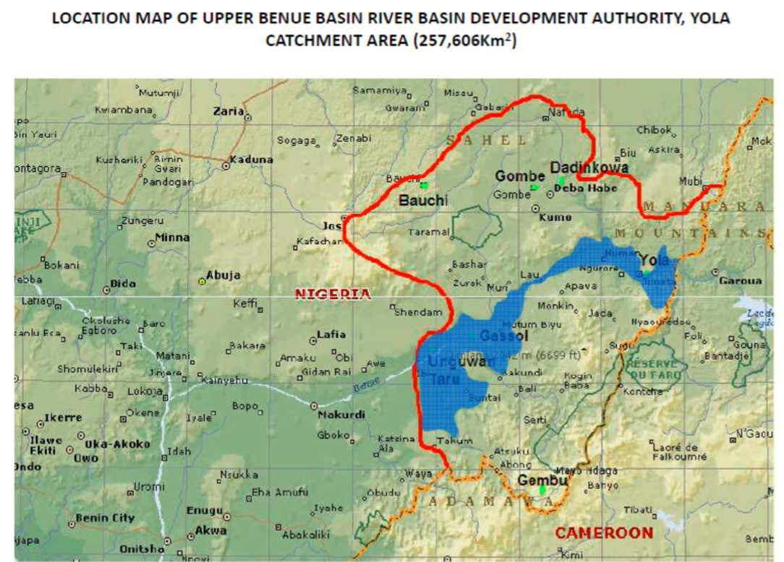
Figure 2.1: Organogram

CHAPTER THREE

3.0 DESCRIPTION OF WORK EXPERIENCE

3.1 AUTOCAD
AutoCAD is a computer design software use by architect and engineers for drafting their floor plan and mechanical drawings for easy work. It makes drawing to be easier in derivation of floor plan and many more other drawing
3.1.1 IMPORTANCE OF AUTOCAD
- It saves time
- It easier than manual drafting
- It is clearer than manual drawing

3.1.2 PAGE SETUP IN AUTOCAD
I was thought how to set page in AutoCAD in two different ways
Lunch AUTOCAD application on your computer
Click on start a new drawing on menu bar
- Click on format
- Go to drawing limit
- Specify lower left Conner (which is 0, 0) then enter
- And also specify upper right Conner which is optional e.g. 10000, 10000 and many other more.
- Click on view and go to zoom all
- Click on format
- Go to units
- Set the precision to zero and the insertion scale to Millimeters.
- Set your dimension style and layers and your page is ready for drawing
METHOD 2
- Type limits on your keyboard and hit enter
- Specify lower left Conner and enter and also specify upper right Conner and hit enter
- Type Z and hit enter type A and hit enter.
- Type units on your keyboard and hit enter
- Set the precision to zero and the insertion scale to Millimeters
- Set your dimension style and layers and your page is ready for drawing.
3.1.3 SOME AUTOCAD TOOLS
Line Tool: The Line tool is used to draw straight lines between two points. It is one of the most fundamental tools in AutoCAD and is often used to create the basic shape or outline of a design, such as walls in a floor plan or edges in a mechanical drawing.
Circle Tool: This tool is used to draw circles by specifying the center point and radius. It is useful for creating round objects or features such as holes, wheels, or circular openings in architectural and engineering designs.
Trim Tool: The Trim tool is used to cut off or remove unwanted parts of an object. It works by selecting a cutting edge (another object) and then choosing the part you want to remove. It helps in cleaning up drawings and making them more precise.
Offset Tool: The Offset tool creates a copy of a selected object at a specified distance. It is often used to draw parallel lines, such as the inner and outer walls of a building or lanes on a road. This ensures uniform spacing and symmetry in design.
Move Tool: This tool is used to move objects from one location to another within the drawing. It helps in adjusting the position of elements without needing to redraw them, making layout corrections and modifications easier.
Dimension Tool: The Dimension tool allows you to add measurement annotations to your drawings. It can show the length of lines, distances between objects, angles, and more. This is essential for making your design understandable to builders, manufacturers, or clients.
Layer Tool: The Layer tool helps organize your drawing by placing different types of objects on separate layers. For example, walls can be on one layer, electrical elements on another, and furniture on a third. This organization makes editing easier and improves drawing clarity.
3.1.4 DRAFTING OF FLOOR PLAN IN AUTOCAD
I was thought how to draft a floor plan AutoCAD using the construction line in the draw tool bar which will be drawn in vertical and horizontal lines and also offsetting the lies into the required distance needed for a wall and rooms respectively
TRIMING: Trimming of the excess lines that crosses each other on the vertical and the horizontal axis and also for getting a better finishing
EXTENDING: extending of short lines on the vertical and the horizontal lines to rich its meeting point where it is supposed to be in the creation of a floor plan
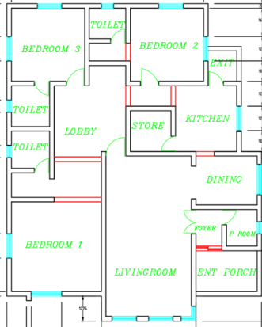
Figure 3.1: AutoCAD floor plan

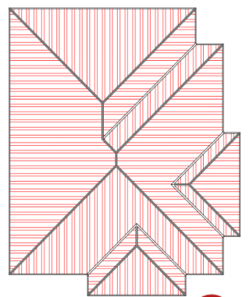
Figure 3.2: AutoCAD floor plan

3.2 SITE CLEARANCE
For the site clearance process, our team took several key steps to ensure the site was ready for construction. First, we gathered all necessary equipment, including shovels, chainsaws, and safety gear, and reviewed the site plan to ensure we understood the requirements. We made sure to obtain the necessary permits and took the time to discuss safety precautions. Next, we cleared the vegetation, carefully handling any environmentally sensitive plants. Construction debris and obstacles like rocks and concrete slabs were removed using heavy machinery, ensuring the site was free of obstructions. Excavation and grading were carried out to level the site and guarantee proper drainage for a solid foundation. Throughout the process, we managed waste responsibly, disposing of both hazardous and non-hazardous materials according to regulations. Finally, a thorough inspection was performed to ensure the site was clean, safe, and fully prepared for the next phase of development.

3.3 SETTING OUT
The Square Method was used to accurately set out rectangular or square buildings by ensuring all corners formed perfect right angles. It was based on the 3:4:5 rule from Pythagoras’ Theorem. The process involved measuring and pegging out straight lines, adjusting angles to form right corners, and confirming accuracy by checking diagonals. This method helped prevent construction errors and ensured the building's structural integrity. As noted by an engineer, accurate calculations during setting out were crucial for the building’s durability.
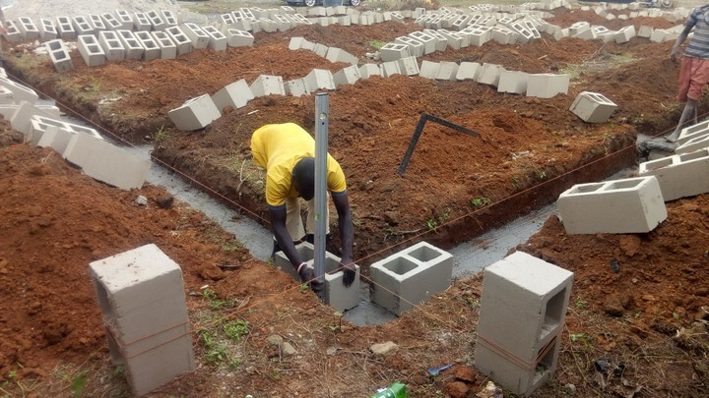
Plate 3.1: Setting out using builder square
Source: Author’s work, 2025

3.4 EXCAVATION OF FOUNDATION
Excavation was carried out as the first major step in the construction process to prepare trenches and holes for pile and strip foundations. The work involved both manual and mechanical methods, depending on the size of the area and the nature of the soil. Key factors considered included soil type, foundation depth, climatic conditions, water table level, and the impact on nearby structures. Strip foundations involved digging continuous trenches, while pile foundations required deeper, square-shaped holes (ranging from 1.2m x 1.2m to 1.4m x 1.4m).
In weak soil areas, a mixture of cement and sharp sand was applied at the base before placing reinforcement baskets to prevent rusting. The entire process was carefully monitored by the site engineer and foreman to ensure accuracy, safety, and structural integrity. Overall, the excavation works were successfully completed with strict adherence to standards, ensuring a solid foundation base for the construction project.
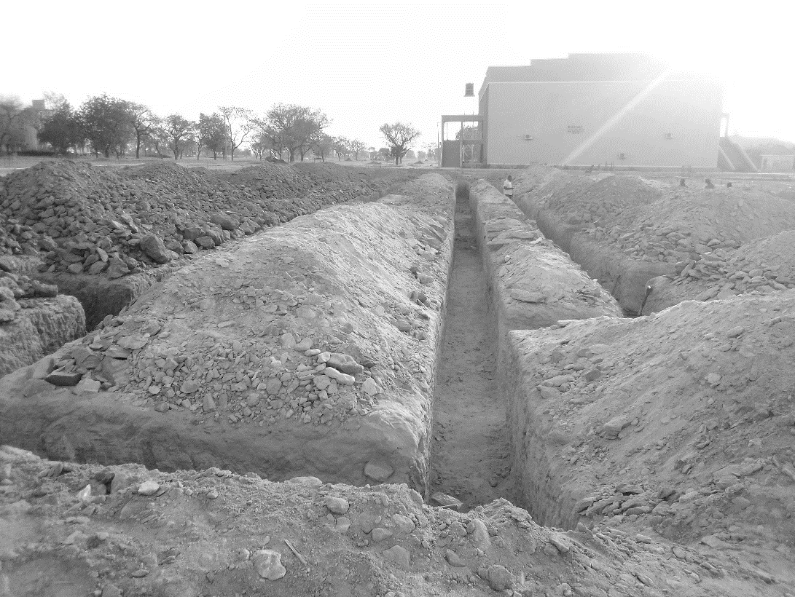

Plate 3.2: Foundation
Source: Author’s work, 2025

3.5 ARCHITECTURAL DESIGNS
During my SIWES, I was able to design a floor plan, lining room, dining area with section and elevation. Fine attached.
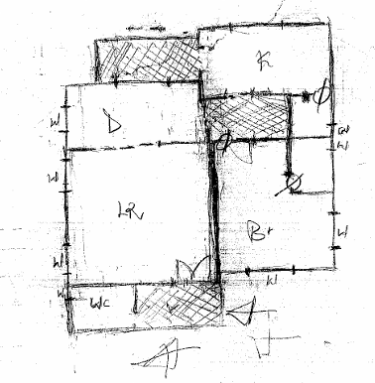
Plate: Sketch of One Bedroom Flat
Source: Author’s work, 2025
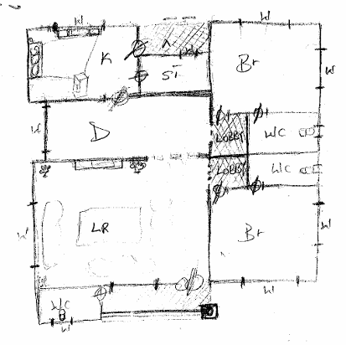
Plate: Sketch of Two Bedroom Flat
Source: Author’s work, 2025

CHAPTER FOUR

4.0 SUMMARY, CONCLUSION AND RECOMMENDATIONS

4.1 PROBLEMS OBSERVED DURING MY PROGRAM
- The duration allocated for the program was insufficient, leading to the inability to cover some important aspects of the training.
- There was a lack of financial assistance from the organization, making it difficult to afford daily transportation to and from the training site.
- The IT students received minimal attention from the staff; learning was mostly self-driven and required personal initiative to ask questions or seek guidance.

4.2 SUMMARY
Discipline can be described as the development of both the mind and body to ensure effective performance. The Students Industrial Work Experience Scheme (SIWES) has made remarkable strides in this area by complementing theoretical knowledge acquired in the classroom with practical, hands-on industrial experience. It offers students the opportunity to engage actively in real-life operations within the industry and commercial sectors.
Throughout the program, emphasis was placed on adherence to safety regulations, timely task execution, effective human resource management, and quality control practices. These objectives collectively aim at enhancing productivity and producing goods and services that meet market standards.
To further strengthen the benefits of this initiative, it is essential for SIWES coordinators at higher institutions to be empowered to provide input and suggestions for improving the program’s overall impact.

4.3 CONCLUSION
The SIWES program plays a critical role in the education of undergraduates by bridging the gap between theory and practice. It provides a platform for students to apply the knowledge gained in the classroom to real-world job scenarios. Moreover, the program fosters collaboration among students from diverse institutions and academic backgrounds, promoting shared learning and teamwork, which are vital in professional environments.

4.4 RECOMMENDATIONS
Based on the experience gained during the SIWES program, the following recommendations are suggested:
- Tertiary institutions, including universities and polytechnics, should establish strong partnerships with companies and industries. This collaboration will help secure placement opportunities for students and potentially open doors for future employment.
- Students should view the SIWES program as more than just a source of financial benefit. The focus should be on acquiring practical experience and industry exposure, which are invaluable for career development.

REFERENCES
Ekpenyong, L. E. (2011). Foundations of Technical and Vocational Education: Evolution and Practice. Benin City: Ambik Press.
National Board for Technical Education (NBTE). (2004). SIWES Operational Guide. Kaduna: NBTE Publications.
Okorie, J. U. (2001). Vocational Industrial Education. Bauchi: League of Researchers in Nigeria (LRN).
Uvah, I. I. (2004). Repositioning SIWES for Sustainable Industrial Development in Nigeria. Journal of Technical Education, 3(2), 44–52.

